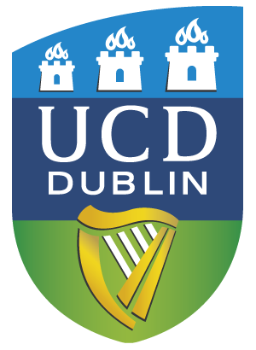


The Heritage Council School of History Bursary
MA Archives and Records Management

APPLICATION FORM 2025/2026
Please consult the Terms and Conditions of the Scholarship

1. Name:__________________________________________________________________

2. Student/ application number:_________________________________

3. Email:______________________________

4. Previous Degrees:__________________________

5. Statement of Case: (Please consult paragraph 8 of the “Terms and Conditions”). The statement must not exceed 1,000 words.

6. Applicants must have been offered and have accepted a place on the UCD School of History MA in Archives and Records Management programme.

7. DECLARATION
I declare that the above particulars are correct and understand that the “Terms and Conditions” apply. If I receive any other awards or scholarships, I will inform the School. I accept that failure to abide by the “Terms and Conditions” may disqualify me from this Scheme

Signature of Applicant_____________________________Date________________________

Please return to gradhistory@ucd.ie

not later than 12.00 noon, on Friday 11 ^{th} July 2025

